FPGA Activity

  - Authors: Gabriel Ghrayeb, Karnan Thamilchelvan, Owen Grimm, Syed Fuzail Farhan
  - Downloading Quartus
- Go to the Intel FPGA Download Page
  - https://www.intel.com/content/www/us/en/software-kit/849770/intel-quartus-prime-lite-edition-design-software-version-24-1-for-windows.html
- Choose the Correct Version
  - Select version 24.1(Latest) from the drop-down menu.
  - Please verify that you have selected the following parameters. FPGA Development < Quartus Prime Lite < 24.1 (Latest) < Windows
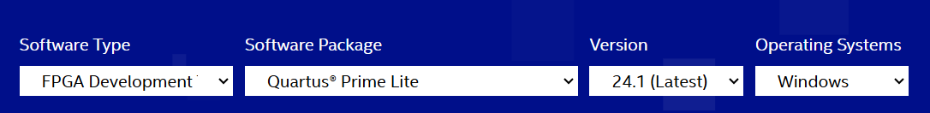
  - Once satisfied, press the download button below and accept the legal disclaimer when prompted.
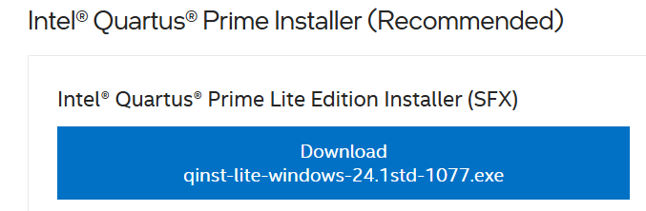
  - Your zip file will now be downloaded, open the folder to begin the setup process. If your file has not downloaded, please click the link to redownload the zip folder.
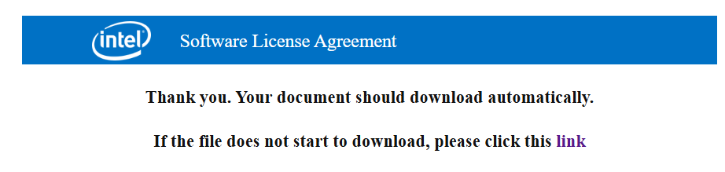
  - Check off the following components.
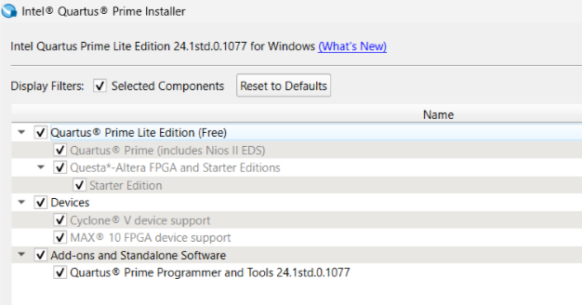
  - Select the Intel License Agreement and click Download and Install. This installation will take a while to complete. Please be patient.
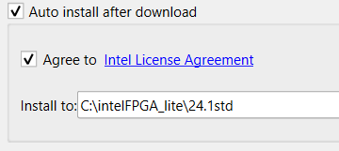
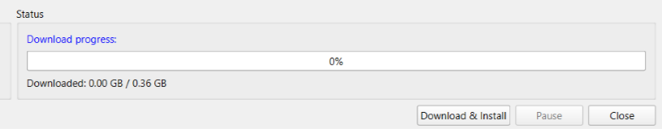
  - Once the download and installation are complete, close the window and open up Quartus. You should see a screen that looks like this:
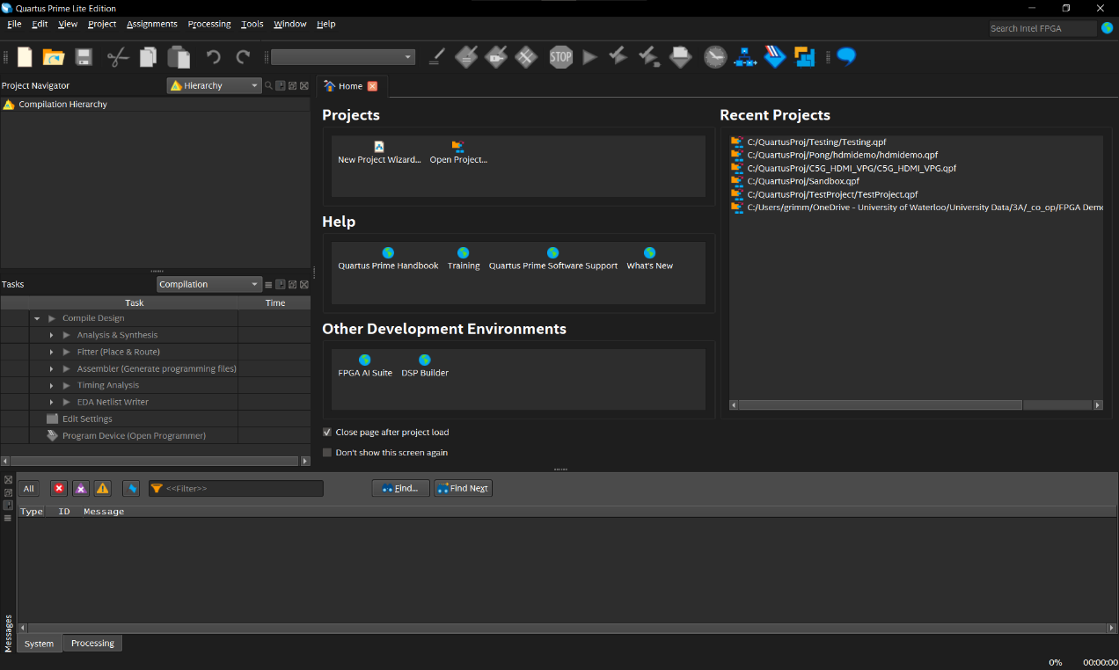

Background

FPGA
FPGA stands for Field-Programmable Gate Array. It's a special kind of chip that you can program to do almost any digital task by wiring it up the way you want—kind of like building your own custom circuit inside a chip. Unlike a microcontroller, which runs one set of instructions step by step (like a tiny computer), an FPGA lets you create many operations that can all run at the same time. This makes FPGAs great for things that need to be fast or happen all at once, like video processing or controlling hardware. People choose FPGAs when they need more speed, more control, or special features that regular microcontrollers can't handle.

VHDL
VHDL stands for Very High-Speed Integrated Circuit Hardware Description Language. VHDL is an HDL (Hardware Description Language) and is used to program digital circuits. Unlike Python, Java and C, which use whatever hardware they are on to implement software, HDLs describe the function and structure of a digital circuit hardware. Like any other programming language you have seen, VHDL has a particular syntax that must be followed.

Inputs and Outputs
In VHDL, inputs and outputs are how your circuit communicates with the outside world. When you describe a digital circuit in VHDL, you need to tell the computer what signals come in (inputs) and what signals go out (outputs). This is done in the entity section of your VHDL code.
Inputs are values that the circuit receives (like buttons, switches, or signals from other circuits).
Outputs are values that the circuit sends out (like turning on a light or sending a signal to another component).

Design Entity
An entity is a VHDL building block that defines all the inputs and outputs of the overall system. Think of it as a black box which is a representation of a system that relies entirely on inputs and outputs.
There can only be one entity definition per file. The name of an entity should always be the file name. Notice that only the last element in the list is not followed by a semicolon – this is relevant to the syntax and occurs in other blocks. Everything inside the PORT brackets defines the inputs and outputs of the VHDL file.
In the image below, inputs and outputs are declared as std_logic which means they can be 0 or 1 value.
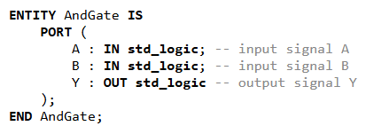

Architectural Body
The architectural body in VHDL is the part of the code that describes what the circuit actually does. It is connected to an entity, which defines the overall inputs and outputs.
You can think of the entity as the outside of a box (the ports), and the architecture as what’s happening inside the box (the logic).
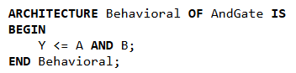

Libraries
Like standard programming languages, VHDL uses libraries for added functionality. For our purposes, we will be using one library: IEEE, specifically std_logic_1164, and numeric_std. The IEEE library defines a bunch of functionalities as regulated by the Institute of Electrical and Electronics Engineers. The std_logic library defines relevant data types and functions, while numeric_std allows for arithmetic operations. You will not need the numeric library until the bonus activity.
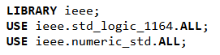

Boolean Expressions
Boolean expressions are logical statements that combine input signals to determine an output. They use logic operations like AND, OR, NOT, and XOR, which are the building blocks of all digital circuits.
The assignment operator in VHDL is “<=” and it is used to assign a value to a signal.
Operator | Meaning | VHDL Example
AND | Logical AND | Y <= A AND B;
OR | Logical OR | Y <= A OR B;
NOT | Logical NOT | Y <= NOT A;
NAND | NOT AND | Y <= A NAND B;
NOR | NOT OR | Y <= A NOR B;
XOR | Exclusive OR | Y <= A XOR B;
XNOR | Exclusive NOR | Y <= A XNOR B;
NOTE: NAND and NOR gates can also be expressed as an AND or OR gate, respectively, followed by a NOT gate, with intermediate values stored using signals. You are also not limited to a single operation per line.
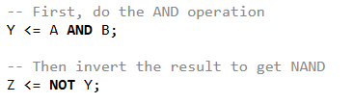

Sample VHDL Program
Here’s a sample program that shows you how the library, design entity, architectural body and Boolean expressions all go together:
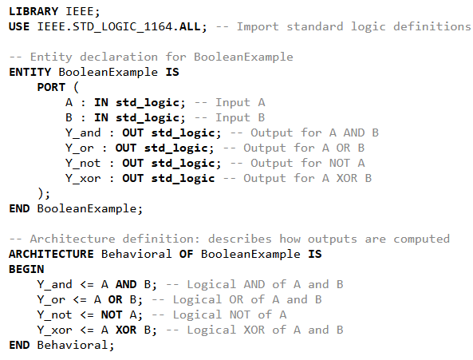

Driver Installation
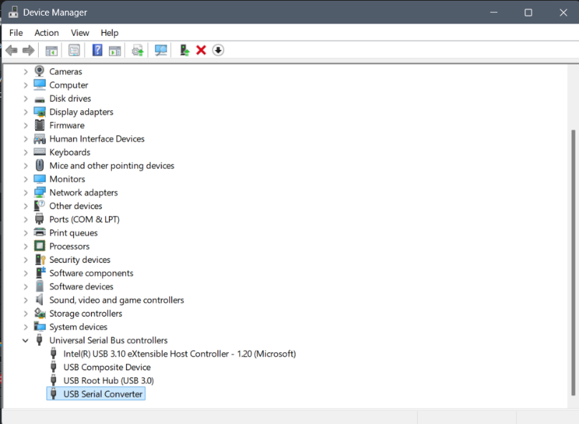
For Quartus to detect your FPGA, you will need to install the USB-Blaster drivers. Your FPGA will need to be plugged into power, as well as your computer to do this. MAKE SURE THAT THE USB-B END OF YOUR CABLE IS PLUGGED INTO THE PORT ON YOUR FPGA LABELED AS “USB-Blaster” (The one that is closest to the edge of the board). To do this, navigate to Device Manager. The FPGA will be labeled as either an unknown device, or something like USB Serial Converter (you can figure out which device corresponds by unplugging and plugging in the FPGA and seeing which device appears and reappears).
Double click on the device and navigate to the driver tab. Click on “Update Driver”
.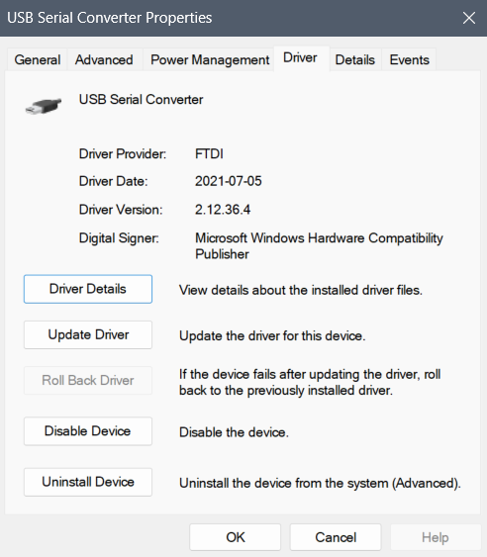
Click on “Browse my computer for drivers”
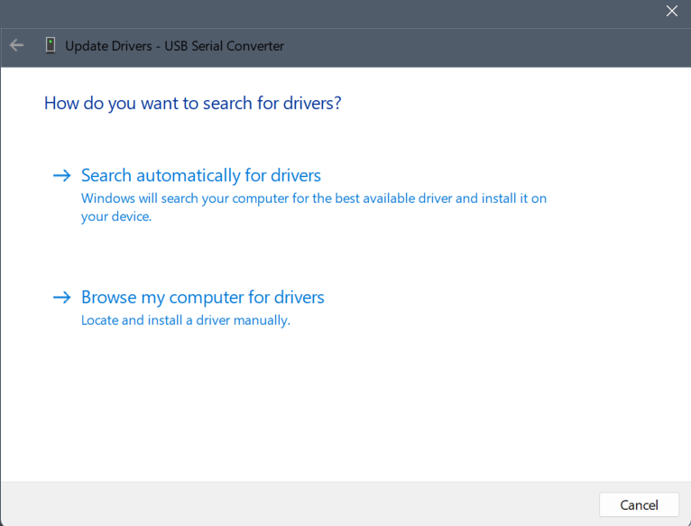
Click on “Let me pick from a list of available drivers on my computer”.
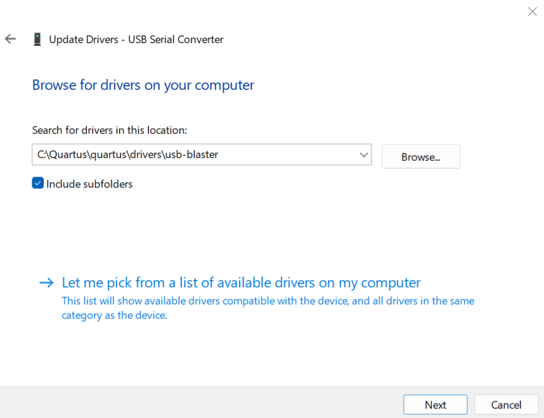
Click “Browse” and navigate to quartus\drivers\usb-blaster or intel_fgpa\quartus\drivers\usb-blaster or something similar. The file you are looking for is usb-blaster. Click OK.

Driver troubleshooting:
If you’re unable to update the drivers using the previously mentioned approach you can try the following approaches to see if that works.
Alternative 1:
Instead of just selecting the folder, you can select the file directly. Similar to the previous step, we need to get to the usb-blaster folder and then follow the path usb-blaster >> x64 >> .inf file (there should only be one file and that’s the one which should be selected) and just select that file.
Alternative 2:
It’s also possible to install the driver package online using the following link and its respective instructions https://www.terasic.com.tw/wiki/Windows_encountered_a_problem_installing_the_drivers_for_your_device
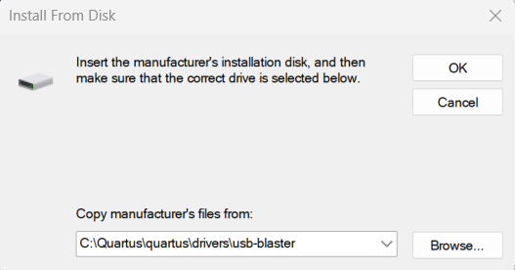
Select “Altera USB-Blaster" and click Next.
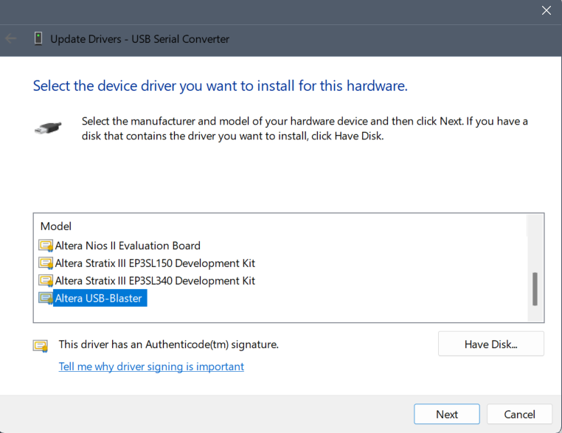
The drivers should now be installed.

Part 1 – Testing out the System

Creating your First VHDL Project
Your first VHDL project is to implement the Boolean example below. You’ll map the A and B inputs to switches and each of the four outputs to an LED. You will reuse these steps in the later activities to create new projects.
----------------------------------------------------------------------------------------------
LIBRARY IEEE;
USE IEEE.STD_LOGIC_1164.ALL;

ENTITY BooleanExample IS
PORT (
SW : IN STD_LOGIC_VECTOR(1 DOWNTO 0);
LEDR : OUT STD_LOGIC_VECTOR(3 DOWNTO 0)
);
END BooleanExample;

ARCHITECTURE Behavioral OF BooleanExample IS
BEGIN
LEDR(0) <= SW(0) AND SW(1); -- AND
LEDR(1) <= SW(0) OR SW(1); -- OR
LEDR(2) <= SW(0) XOR SW(1); -- XOR
LEDR(3) <= NOT SW(0); -- NOT A
END Behavioral;

----------------------------------------------------------------------------------------------

- Open Quartus Prime
  - Launch Quartus Prime from your computer.
- Create a new project
  - Click File > New Project Wizard
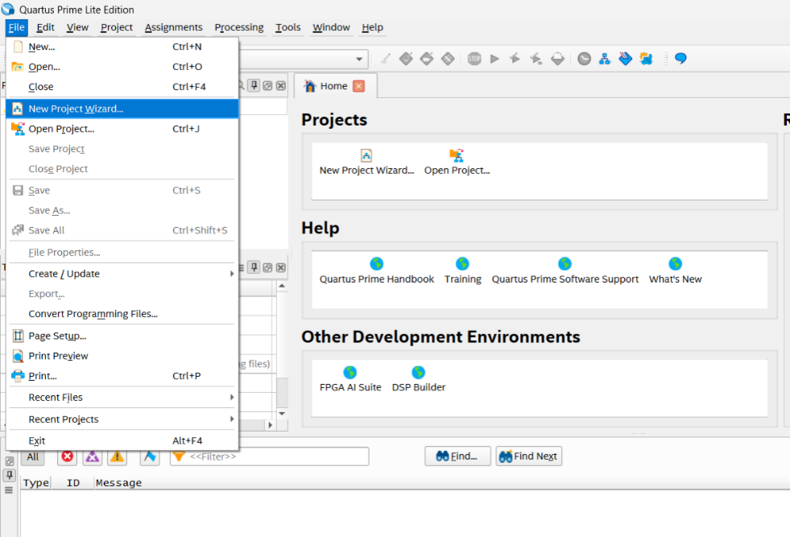
  - Click Next to start the wizard. You should see a screen that looks like this:
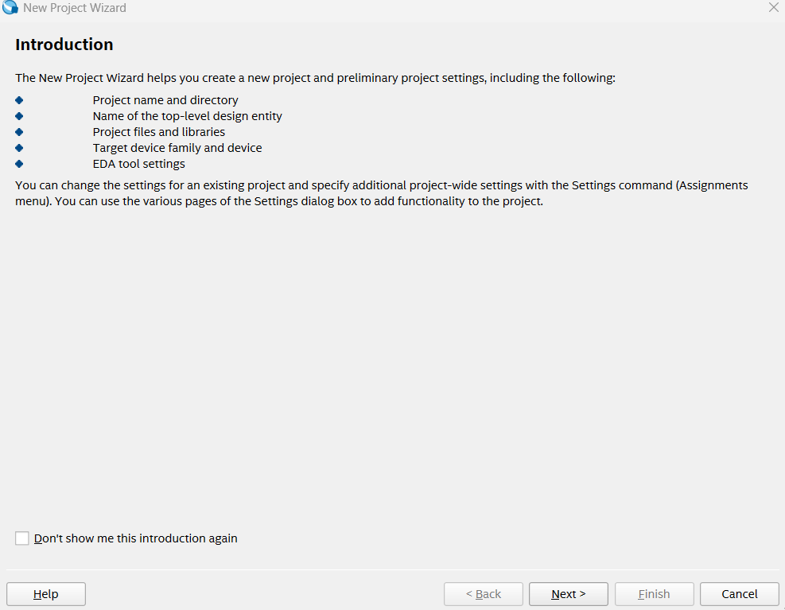
- Choose Project Folder and Name
  - Create a folder named FPGA_Projects\BooleanExample in your C drive where your project will be saved. (C:\FPGA_Projects\BooleanExample)
  - Give your project a name (BooleanExample)
  - Click Next
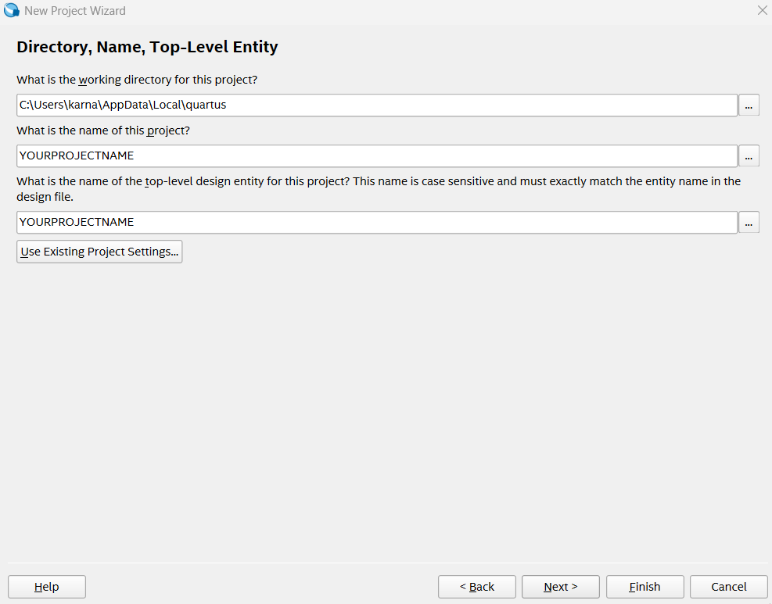
- Empty Project and Add Files
  - Select Empty Project and click Next.
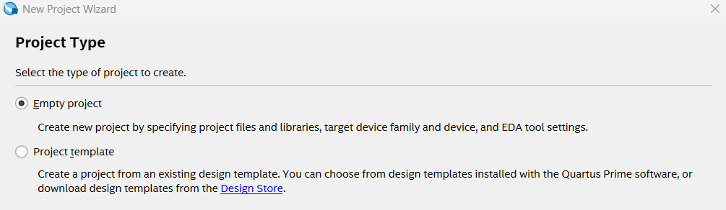
  - Click Next. We will skip the Add Files section.
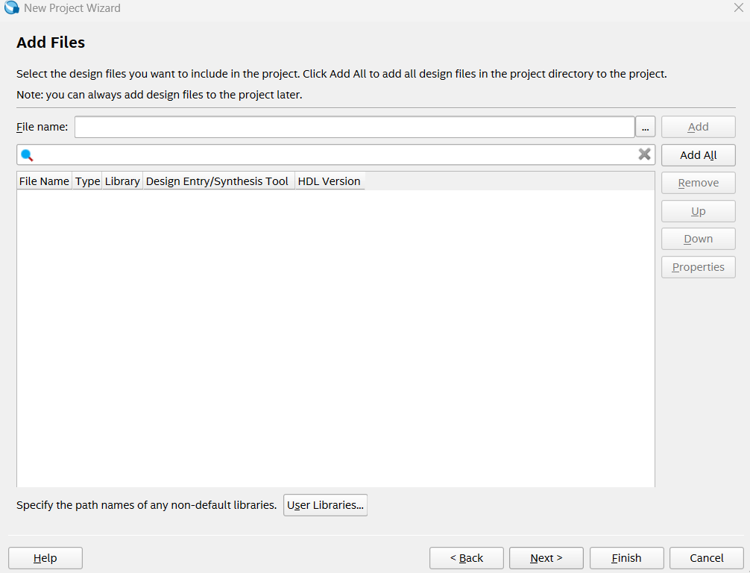

- Select the FPGA Device
  - Choose your specific FPGA chip.
    - Select Board
    - BOARD > Cyclone V GX Starter Kit
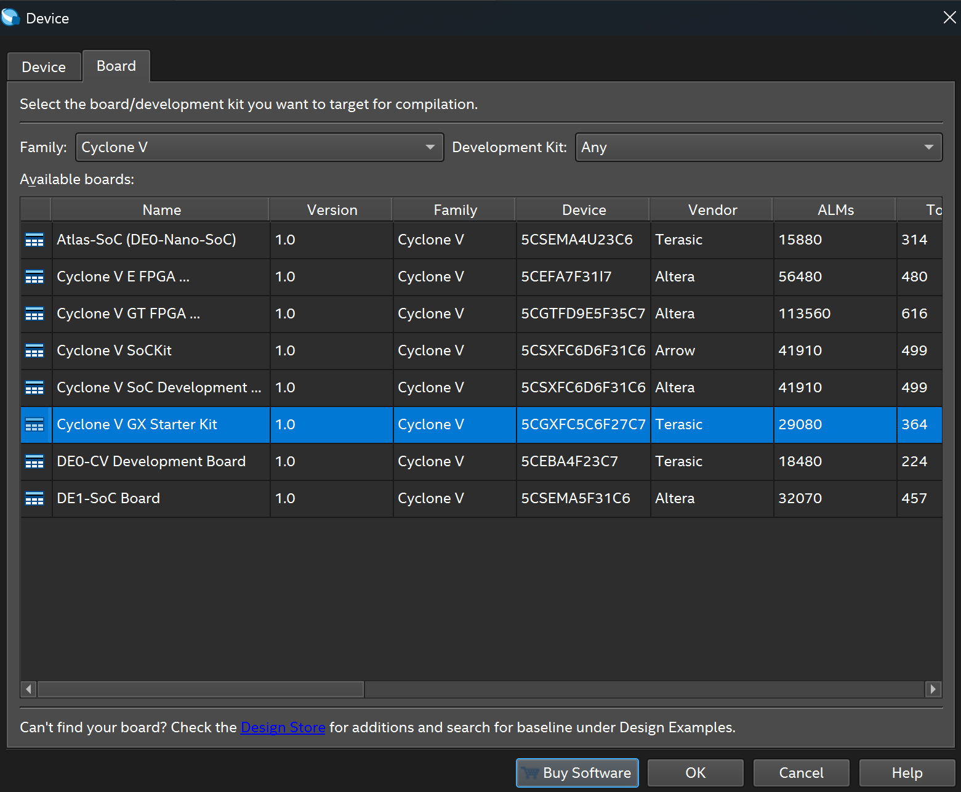
  - Click Next

- EDA Tool
  - Ensure the 'Simulation’ has ‘Questa Intel FPGA’ and ‘VHDL’ selected.
  - Click Next

- Summary
  - Click Finish to complete project setup.
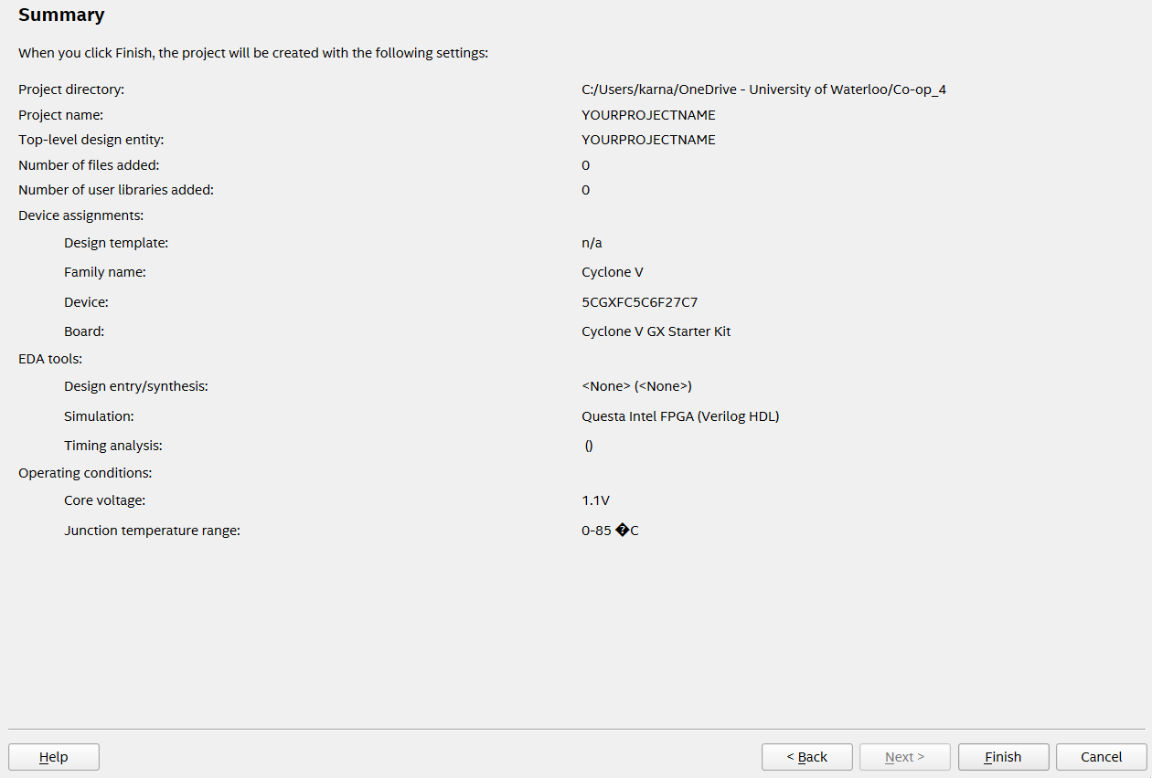
- Create a New VHDL File
  - You are ready to create a VHDL file now. Click File > New
  - Choose VHDL File
  - Click OK
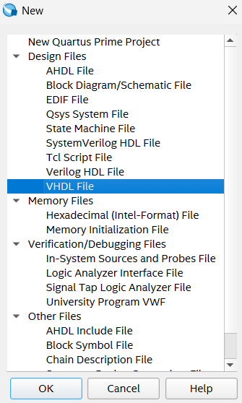
- Cut and paste this code (BooleanExample) into your VHDL file
----------------------------------------------------------------------------------------------
LIBRARY IEEE;
USE IEEE.STD_LOGIC_1164.ALL;

ENTITY BooleanExample IS
PORT (
SW : IN STD_LOGIC_VECTOR(1 DOWNTO 0);
LEDR : OUT STD_LOGIC_VECTOR(3 DOWNTO 0)
);
END BooleanExample;

ARCHITECTURE Behavioral OF BooleanExample IS
BEGIN
LEDR(0) <= SW(0) AND SW(1); -- AND
LEDR(1) <= SW(0) OR SW(1); -- OR
LEDR(2) <= SW(0) XOR SW(1); -- XOR
LEDR(3) <= NOT SW(0); -- NOT A
END Behavioral;

----------------------------------------------------------------------------------------------
- Save your VHDL File
  - Select File > Save As
  - Enter your file name.
  - Click Save as type > VHDL File
  - Click the check mark box to add your file to the project you created.
  - Click Save
  - Add your VHDL code and save it!

Compilation
- Click Processing > Start Compilation or click the blue play button (Compilation is a slow process there will be a progress bar at the bottom corner)
- Compilation will provide a success prompt. Please fix any errors that appear in the terminal and then re-compile.
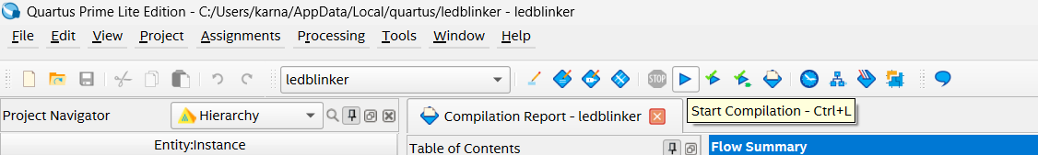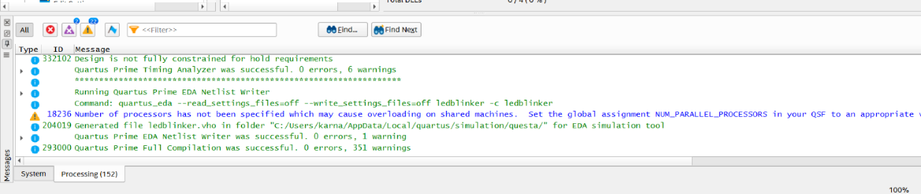

Top File Entity
- Select Assignments > Settings > General
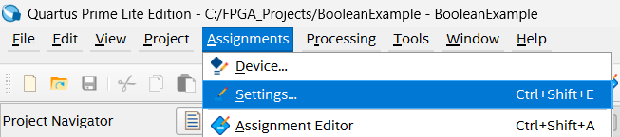
- Replace the default top file entity by selecting the 3 dots.
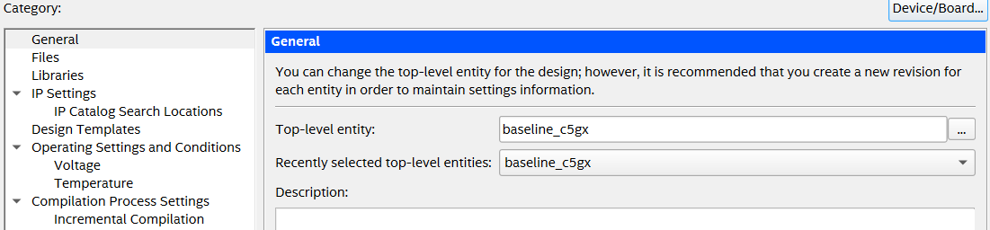
- Click on your new top file entity (BooleanExample). Select OK.
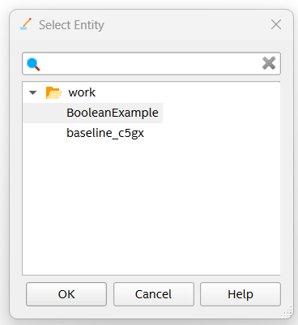
- Select OK again.
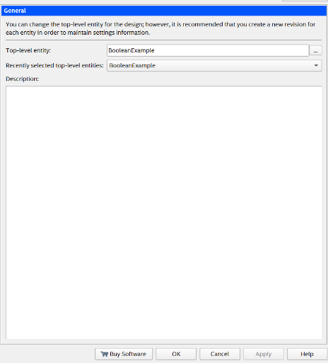
- Select Processing > Start Compilation again.

Programming the FPGA
Materials required:
- USB Blaster Cable.
- FPGA board connected to your computer.

- Open Programmer Tool
  - Go to Tools > Programmer
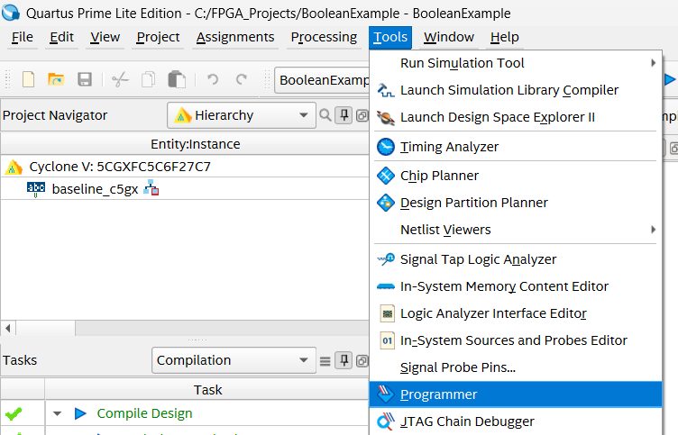
- Check Hardware Setup
  - In the Programmer window, click Hardware Setup (If you see “No Hardware” then click Add Hardware and choose USB Blaster and click OK.
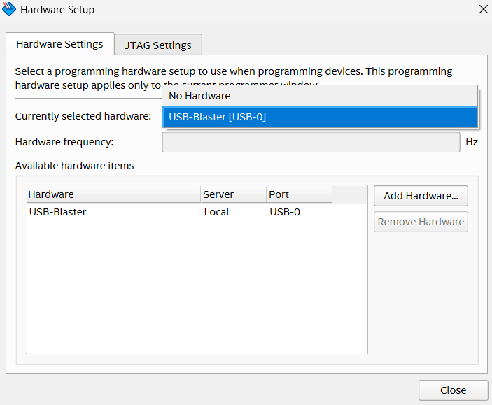
- Add .sof file
  - You should see a .sof file. Select this file.
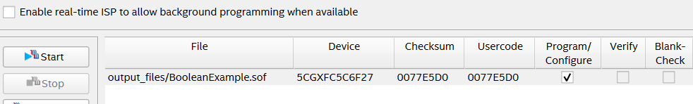
- Start Programming
  - Click the Start button.
  - Your program will be uploaded to the board once the progress bar reaches 100%.
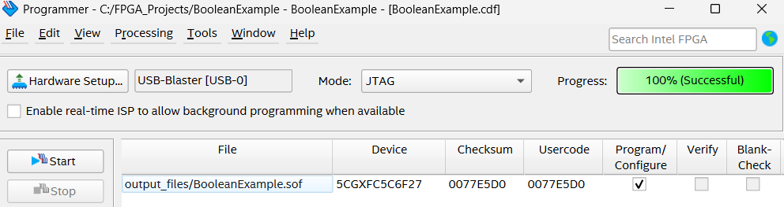
- After successfully uploading your program, please verify that you are receiving the expected outputs below.
Inputs |  | Outputs
SW(1) | SW(0) | Operators | LED is ON
0 | 0 | NOT | LEDR(3)
0 | 1 | OR, XOR | LEDR(2), LEDR(1)
1 | 0 | NOT, OR, XOR | LEDR(3), LEDR(2), LEDR(1)
1 | 1 | OR, AND | LEDR(1), LEDR(0)

Part 2 – Implementing Circuits

Signals
Most VHDL code defines a more complex circuit than the gates in the last example. So we need the equivalent of physical ‘wires’ to connect the gates. In VHDL these ‘wires’ are called signals.
Each signal you need for your circuit must be declared as a specific data type. It is declared inside the Architecture block. It isn’t declared as an input or output because it is just a “wire” between components.
Some datatypes for signals include std_logic, integer, Boolean, signed/unsigned.
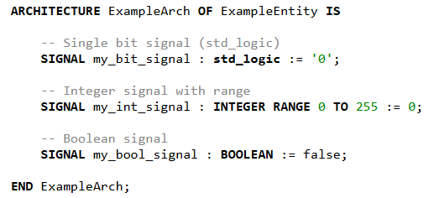
Here’s what code would look like to implement the circuit X = (A AND B) OR C:
----------------------------------------------------------------------------------------------
library IEEE;
use IEEE.STD_LOGIC_1164.ALL;

entity LogicExample is
Port (
SW : in STD_LOGIC_VECTOR(2 downto 0); -- SW[0] = A, SW[1] = B, SW[2] = C
LEDR : out STD_LOGIC_VECTOR(0 downto 0) -- LEDR[0] = X
end LogicExample;

architecture Behavioral of LogicExample is
signal AB : STD_LOGIC; -- internal wire for A AND B
begin
AB <= SW(0) and SW(1); -- A AND B
LEDR(0) <= AB or SW(2); -- (A AND B) OR C
end Behavioral;
----------------------------------------------------------------------------------------------

Ativity 1 – Create your first project! (Full Adder)
The first activity is to implement an FPGA circuit that adds two bits together. Some of you may recognize this as a full adder circuit.
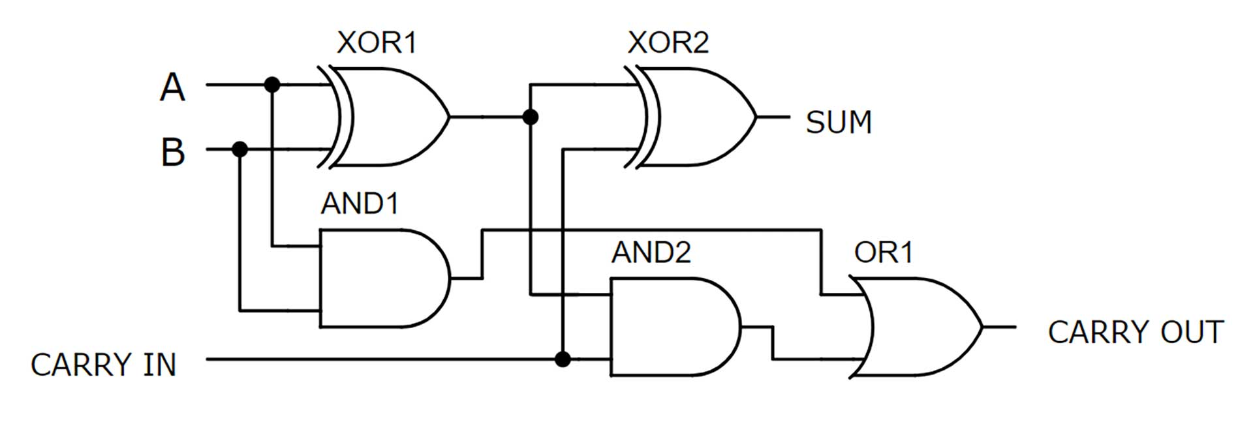
The input will be the switches on your FPGA, where SW0 is input A, SW1 is input B, and SW2 is the Carry In bit. The sum and carry out bits will be output to LEDs 0 and 1 respectively.
Follow the same procedure in the Creating your First VHDL Project section.
Use this table to verify that your circuit is working properly. The first part is completed for you. The Sum is the sum of A+B+Carry In, but because it’s only one bit long, when the sum is 2 or 3 there is a carry to the next column (Just like when you learned how to do addition of big numbers back in primary school).
Input |  |  | Output
A | B | Carry In | Carry Out | Sum
0 | 0 | 0 | 0 | 0
0 | 0 | 1 | 0 | 1
0 | 1 | 0 | 0 | 1
0 | 1 | 1 | 1 | 0
1 | 0 | 0
1 | 0 | 1
1 | 1 | 0
1 | 1 | 1
That concludes this activity. Now that you can implement a circuit, it’s time to introduce a few more useful aspects of FPGAs.
Helpful tip
It’s possible to view the logic circuit generated by you VHDL code by doing the following.
- After compilation, expand the “Analysis & Synthesis” tab shown below
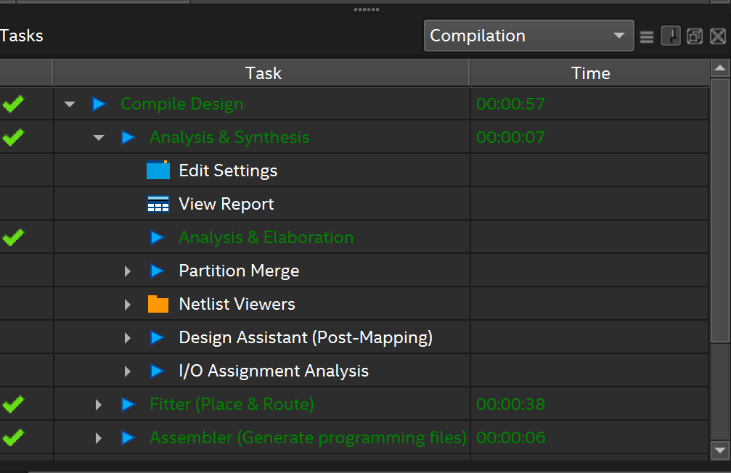
- Expand the “Netlist Viewers” then click on the “RTL Viewer”
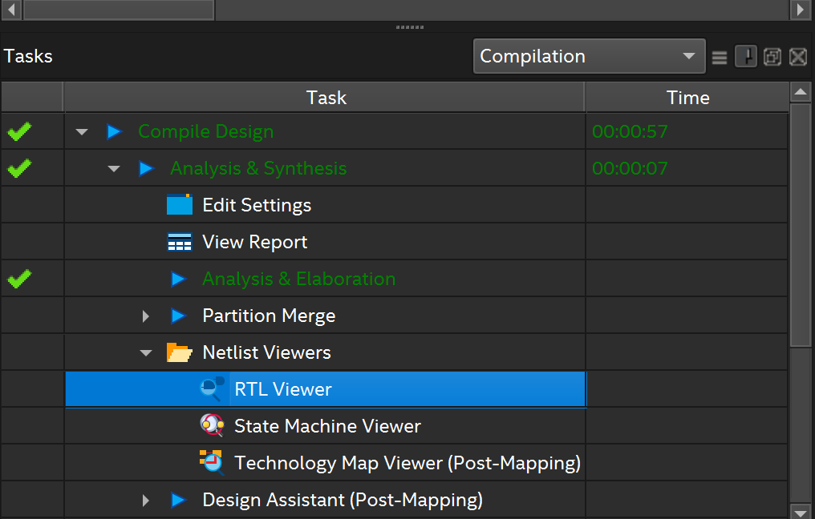
- Then you should be able to see the logic circuit that corresponds to your VHDL code
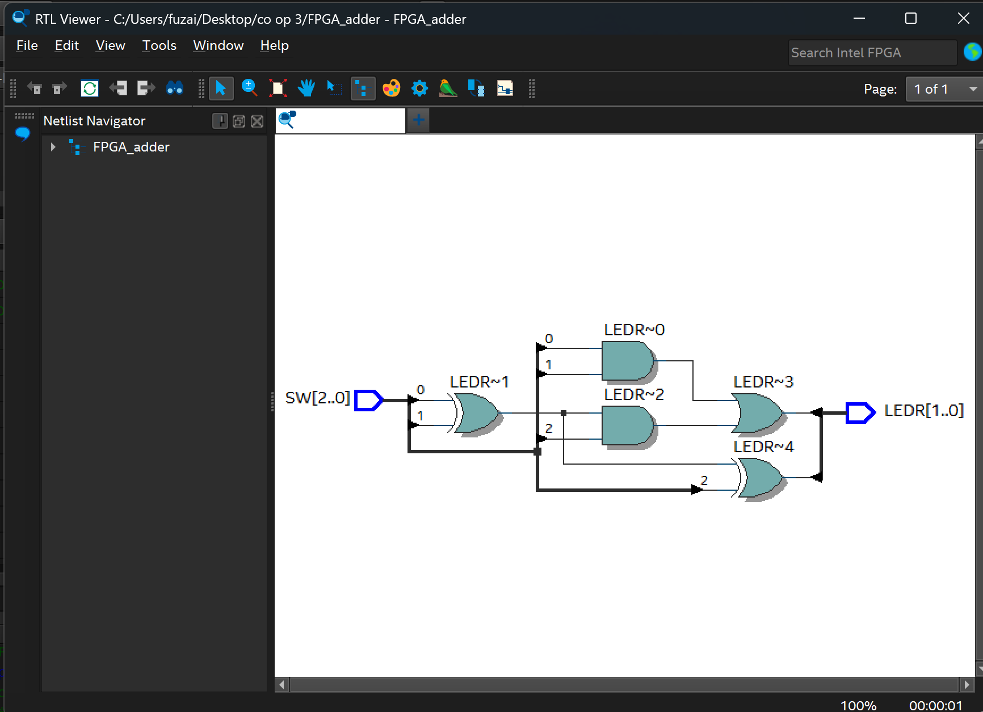

Part 2: Seven-Segment Displays
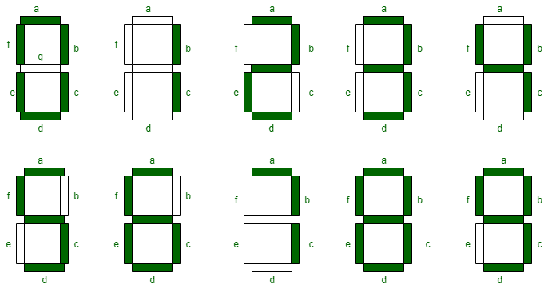
To drive the seven-segment display, a seven-digit binary number, formatted as “abcdef”, is assigned to the display, using the following syntax.
HEX0 <= "gfedcba";
This code corresponds to the seven-segment display closest to the right side of the board. The display is active low, so to turn a segment on, it should be assigned a 0. So, to display the digit 7 on the rightmost display the instruction would be
HEX0 <= "1111000";
**NOTE regarding the use of quotation marks. For vectors, e.g., std_logic_vector, double quotation marks (") should be used, such as for driving the seven-segment display. For individual logic states, e.g., std_logic, single quotation marks (') are used.

Process
A process is a section of the code that will run whenever it is triggered. This trigger could be whenever a button is triggered, a switch is turned, or the value of an internal signal is changed. Variables to be used within processes are declared outside of the core code of the process.
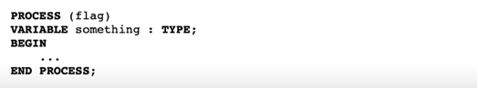

If Else Statement
An if statement is used to make decisions based on certain conditions, just like it is done in regular programming languages. It allows you to select between different actions or signal assignments depending on whether a condition is true or false.
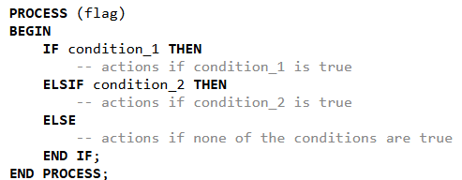

Sample Code
This is a simple script that checks the value of two switches, and if they are high, displays a 1 on the seven-segment display. Otherwise, the display shows 0. You can use this as a reference for the following activity to understand the syntax.
LIBRARY IEEE;
USE IEEE.STD_LOGIC_1164.ALL;

ENTITY SegExample IS
PORT (
SW : IN STD_LOGIC_VECTOR(1 DOWNTO 0);
HEX0 : OUT STD_LOGIC_VECTOR(6 DOWNTO 0) -- 7-seg display (active-low)
);
END SegExample;

ARCHITECTURE Behavioral OF SegExample IS
BEGIN
PROCESS (SW)
BEGIN
IF (SW(0) = '1') AND (SW(1) = '1') THEN
HEX0 <= "1111001"; -- Display "1"
ELSE
HEX0 <= "1000000"; -- Display "0"
END IF;
END PROCESS;
END Behavioral;

Activity 2 – From Switch to Display
The goal of this activity is to drive the seven-segment display using on-board switches. Each switch being flipped should correspond to a number being displayed on the board, e.g. when SW3 is flipped; a 3 is displayed on the seven-segment display.
To write the architecture of this VHDL code, start by declaring a signal to temporarily store the number corresponding to the active switch. Then, create a process that monitors the state of all input switches. Use a series of if statements to determine which switch is turned on, giving priority to the one with the lowest index. When a switch is found to be active, assign its index value (in binary) to the signal. If no switches are on, assign a default value to indicate "no input." Next, create another process to handle the conversion of that binary number into the correct 7-segment display pattern. Use a case statement to match each binary number to its corresponding 7-segment output code. Finally, ensure the output is assigned to the 7-segment display port, so the number appears on the screen.

Activity 3 – Displaying Logic Circuit Results
This activity also involves displaying numbers using the seven-segment display. Building on the full adder activity, modify your code to display the result of the full adder using the seven-segment display.
To do this, you will need to add two standard logic type signals to your architecture, one for the sum, and one for the carry out. Use a process that triggers whenever the state of either of the signals changes. Inside the process, you should use if statements that check the state of the carry out and the sum simultaneously and assign the appropriate value to the seven-segment display. Refer to the truth table below for the expected behavior
Carry Out | Sum | Display
0 | 0 | 0
0 | 1 | 1
1 | 0 | 2
1 | 1 | 3

Part 3 – From Digital to Programmed Logic

Function
A function is a reusable block of code that executes a specific computation and returns a value. VHDL functions are like regular programming languages.
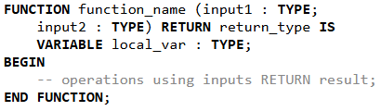

Case Statement
A case statement is like a multiple-choice decision. It checks the value of a signal or variable and executes different code depending on the value.
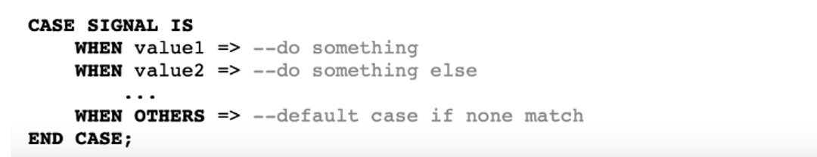

Variables
In VHDL, variables and signals are both used to store data, but they behave differently. Signals represent connections and are used to model hardware wires—they update their values after a delay (in the next simulation cycle). In contrast, variables are used inside processes and update immediately, making them useful for intermediate calculations. Use signals when you want to communicate between processes or drive outputs, and variables when you need quick updates within a single process or function.
In VHDL, := and <= are assignment operators, but they are used in different contexts. The := operator is used to assign values to variables, and the change happens immediately within the process or function. The <= operator is used to assign values to signals, and the change takes effect after the current simulation cycle, reflecting actual hardware behavior. So, use := for quick, local calculations with variables, and use <= when updating signals that represent hardware connections.

Sample Code
This sample code shows the usage of functions and case statements. Again, you can use the syntax of this file as a reference for the following activity.
library IEEE;
use IEEE.STD_LOGIC_1164.ALL;

entity SegExample is
Port (
SW : in STD_LOGIC_VECTOR(1 downto 0);
HEX0 : out STD_LOGIC_VECTOR(6 downto 0) -- 7-seg display (active-low)
);
end SegExample;

architecture Behavioral of SegExample is

-- Function: Convert '0' or '1' (as character) to 7-segment encoding
function to_seven_segment(bit_char : character) return STD_LOGIC_VECTOR is
variable seg : STD_LOGIC_VECTOR(6 downto 0);
begin
case bit_char is
when '0' => seg := "1000000"; -- 7-seg for 0
when '1' => seg := "1111001"; -- 7-seg for 1
when others => seg := "1111111"; -- blank display (all off)
end case;
return seg;
end function;

signal result : STD_LOGIC;

begin

result <= SW(0) and SW(1);

-- Use function to choose display value
process(result)
begin
if (SW(0) = '0' and SW(1) = '0') then
HEX0 <= to_seven_segment('X'); -- undefined → blank
elsif result = '1' then
HEX0 <= to_seven_segment('1');
else
HEX0 <= to_seven_segment('0');
end if;
end process;

end Behavioral;

Activity 4 (optional) – Binary to Decimal Conversion
The goal of this activity is to input a 10-bit signed number in binary, using the switches on the FPGA, and output the number in decimal form on the seven-segment display.

Background

What is Binary?
Binary is a number system that uses only two digits:
- 0 means off
- 1 means on
In contrast to the decimal system (which uses digits 0–9), binary only uses 0 and 1. This is perfect for digital electronics because every signal in a circuit is either low voltage (off) or high voltage (on).

Why Do We Use Binary in Circuits?
Each input device on your FPGA board — like a switch — can be in one of two states:
- Switch up → 1 (on)
- Switch down → 0 (off)
When you flip switches, you create binary numbers. These binary inputs go into your circuit, and the logic you write in VHDL decides what happens next (like turning on LEDs or showing numbers on a display).

Example: Binary Numbers with Switches
If you have two switches:
- SW[1] and SW[0]
The combination of their states creates these binary values:
SW[1] | SW[0] | Binary | Decimal Meaning
0 | 0 | 00 | 0
0 | 1 | 01 | 1
1 | 0 | 10 | 2
1 | 1 | 11 | 3

Each place in binary represents a power of 2. So just like decimal is based on 10s, binary is based on 2s:
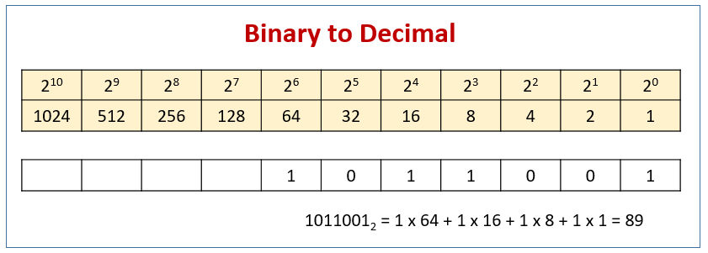

Elements of your VHDL file
For the architecture of this activity, start by defining the following signals:
- Integer type signals
  - One to carry the signed value
  - One to carry the absolute value
  - Signals for the values of the hundreds, tens, and ones places
- A std_logic type signal for the sign bit

Generating Digits
Create a function which takes an integer type input variable, returns a standard logic vector type, and matches it to the seven-digit binary number that will drive the seven-segment display correctly. To do this, use a case statement, which assigns the correct seven-digit binary number to a variable that is returned by the function.

Generating Sign
Create a function that takes a standard logic type input, checks whether it is high or low, and returns a standard logic vector type. If the input is high, return a seven-digit binary number that will display a negative sign. Otherwise, return a value that will result in a blank seven-segment display.

Handling Inputs
Now, create a process block that is triggered by the switches, as you did in the previous activity. You will need to define variables to temporarily hold the signed value of the number, the absolute value, and another signal for temporarily holding intermediate values.
We have given you most of the body code for this process block. Try and understand what is happening as you add it to your code.

Determining the Sign Bit
This part of the code checks whether the most significant bit, the sign bit, is active or not. If it is, it executes the code with converts the binary input from the first 9 switches to decimal and subtracts 512. Otherwise, it just converts from binary to decimal. Then, the value is assigned to the signal which carries the signed value, which you defined earlier.
-- convert input (signed 9-bit number with SW(9) as sign indicator)
if SW(9) = '1' then
temp_signed := to_integer(unsigned(SW(8 downto 0))) - 512;
else
temp_signed := to_integer(unsigned(SW(8 downto 0)));
end if;

signed_val <= temp_signed;

This next part will determine whether the value of the input is greater than or less than 0. Based on that, it will assign either a 0 or 1 to the sign bit signal, and calculate the absolute value of the input, then assign it to the signal which was defined to carry the absolute value.

-- Get the absolute value and sign
if temp_signed < 0 then
temp_abs := -temp_signed;
sign_bit <= '1';
else
temp_abs := temp_signed;
sign_bit <= '0';
end if;
abs_val <= temp_abs;

Decimal Digit Extraction
This section is responsible for decimal digit extraction. Assign the absolute value from the signal to the variable you defined for temporarily storing values. The hundreds digit is extracted and assigned to the signal defined for the hundreds digit by dividing this value by 100. Then, reassign the value of temp as the remainder of the absolute value of the input divided by 100. This value is then divided by 10 to extract the tens place and assigned to the signal defined to carry the tens digit. The digit to be displayed in the ones place is extracted by using remainder division on the temp variable.
----------------------------------------------------------------------------------------------
-- Break into decimal digits
temp := temp_abs;
hundreds <= temp / 100;
temp := temp mod 100;
tens <= temp / 10;
ones <= temp mod 10;
----------------------------------------------------------------------------------------------
--Example: Input=237
hundreds <= temp/100; -- 237/100 = 2
temp := temp MOD 100; -- 237 MOD 100 = 37
tens <= temp/10; -- 37/10 = 3
ones <= temp MOD 10; -- 37 MOD 10 = 7

Incorporate Helper Functions
Now that the rest of the code is implemented, it's time to use the helper functions we wrote earlier.
- Displaying the Sign:
  - Use the sign-generating function (the one that takes a sign bit and returns the corresponding 7-segment code for "+" or "−").
  - Apply this function to the signal that holds the sign bit (e.g., '0' for positive, '1' for negative).
  - Assign the result to the 7-segment display responsible for showing the sign.
- Displaying the Digits (Hundreds, Tens, Ones):
  - Use the digit-to-7-segment function, which takes an integer from 0 to 9 and returns the correct 7-bit code to display that digit.
  - Apply this function to each of the digit signals: hundreds, tens, and ones.
  - Assign the results to the corresponding 7-segment displays for each place value (e.g., hundreds on display 3, tens on display 2, ones on display 1).
This brings us to the end of this activity! Remember to close off your process and your architecture. You can then upload the file to your FPGA and test whether you were successful.

